**Poverty & the City of Louisville**



Overview on Louisville Metro Poverty and Relation to Community Issues

Terrance A. Sullivan, J.D.

March 2015

**Poverty in America**

**What is Poverty and the Federal Poverty Level?**

**Federal Poverty Level (FPL)**

* A measure of income level issued annually by the Department of Health and Human Services. Federal poverty levels are used to determine your eligibility for certain programs and benefits.

**Federal Poverty Level for 2015:**

* $11,770 for individuals
* $15,930 for a family of 2
* $20,090 for a family of 3
* $24,250 for a family of 4
* $28,410 for a family of 5
* $32,570 for a family of 6
* $36,730 for a family of 7
* $40,890 for a family of 8

**National Income Statistics**

* Median household income (dollars) 53,046
* Mean household income (dollars) 73,487

**PERCENTAGE OF FAMILIES AND PEOPLE WHOSE INCOME IN THE PAST 12 MONTHS IS BELOW THE POVERTY LEVEL**

* All people🡪15.4%
* With children under 18 years 🡪17.8%
* Female householder, no husband present 🡪30.6%
  + With related children under 18 years 🡪40.0%

Source: U.S. Census Bureau, 2009-2013 5-Year American Community Survey

**Poverty in Louisville-Metro MSA**

**Quick Facts**

* Median household income (dollars) 44,159
  + Appx $10,000 below national average
* Mean household income (dollars) 62,530
  + Appx $11,000 below national average

**PERCENTAGE OF FAMILIES AND PEOPLE WHOSE INCOME IN THE PAST 12 MONTHS IS BELOW THE POVERTY LEVEL**

* All people 🡪18.4%
  + Under 18 years 🡪26.9%
  + Related children under 18 years 🡪26.5%
* Families with female householder, no husband present 🡪33.7%
  + With related children under 18 years 🡪42.9%

**\*\***On a whole, Louisville workers earn less money and household incomes are well below the national average. In comparison to peer cities, Louisville incomes are lower while poverty rates are higher.

* Poverty is an issue in this community and particularly in the areas west of Interstate 65 with. Census tracts west of I-65 have some areas where median income is $10-12,000 per year.
* Poverty impacts a cities ability to grow and develop. Millennials are more likely to leave Louisville for other markets, including Lexington, for higher wages and job opportunities.
* Poverty can be directly attributed to the growing crime rate around Louisville. The areas with lowest incomes have seen sharpest rise in violent crimes.

Source: U.S. Census Bureau, 2009-2013 5-Year American Community Survey

**My Plan**

**Poverty Eradication Office**

* 1. Location- Downtown, City/Metro Hall, UofL
     1. Staffed with researcher (myself and others hopefully in future), volunteers, policy students from UofL
  2. Purpose- work with the city and other leaders to start a poverty eradication office. I feel that the other two things can be a part of this effort.
     1. Work on grants and finding funding to study ways to eradicate poverty.
        1. Look into other cities and things studies on how other places have lifted people out of poverty.
           1. I had this idea listening to the minimum wage increase debate since I knew that raising the wage has no real impact on poverty level except for like .09%.
        2. I would want to look into policies that have helped in other areas and push forth at the state and local level.

**Logistics**

**Funding**- Funding would be mainly done through grants that are applied for through the office. After researching similar programs, funding for startup would need to be shared by City and/or University and office space. For many federal grants I have found, would need to establish a partnership with UofL and City. Some grants only come in play when partnered with an accredited institution of higher education and other grants require city involvement, so for eligibility would be necessary to work with both. Also would look into local churches like Southeast that have the resources available.

**Partnership with UofL**- would provide base for not only recruiting help, but gaining volunteers. Could work with political science and policy department to set up a ‘for credit’ work opportunity to help do policy research and discuss possibilities and conduct feasibility studies. They would be supervised by acting director of office and however set up through UofL and likely Dr. Jason Gainous of UofL.

University of Louisville Brandeis School of Law offers a public interest scholarship of $2,000 for students who wish to do public interest type work while completing 2nd and 3rd years of Law School

**Goals**- The goal is to work to increase the quality of life of all Louisville residents by working to assist those with the lowest quality of life. The idea is to find and work on policy that would in turn achieve this increase of quality of life. The results may be long term solutions and success will be identified by effectively identifying what needs should be met and finding possible ways to meet them.

**Policy**- Policy will be discussed and researched and scrutinized on its feasibility and effectiveness. The policy can then be discussed with local leaders like the Mayor and Metro Council and work on ways to then get this policy instituted in Louisville if legislative policy is needed.

**Preliminary Research**

**Based on preliminary research, addressing poverty will have the following results:**

* Lower Crime rates
* Educational advancement
* Population growth
* Business growth
* Retain millennial population

**Retain Millennial Work Force**

Between 2007 and 2012, young adults accounted for about 24 percent of the total population of the U.S., but they made up over 43 percent of all movers

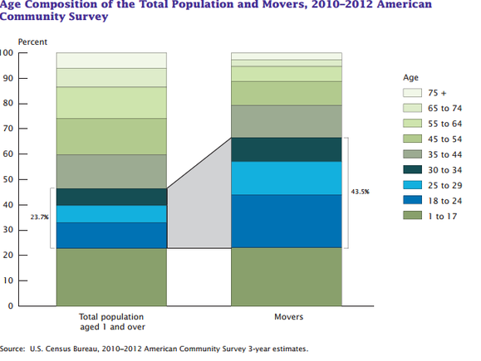

Young Americans want to live somewhere that has opportunity but also has a strong economy to sustain growth.

Louisville is falling behind areas that present greater hope for not only jobs but of a future in which to raise a family and to purchase homes.

**If you look at the map below, Louisville is falling behind to cities that have shown an interest in job growth and investment in the younger workers. Some cities, like Philadelphia, have created programs that help young workers find jobs and train during and after college.

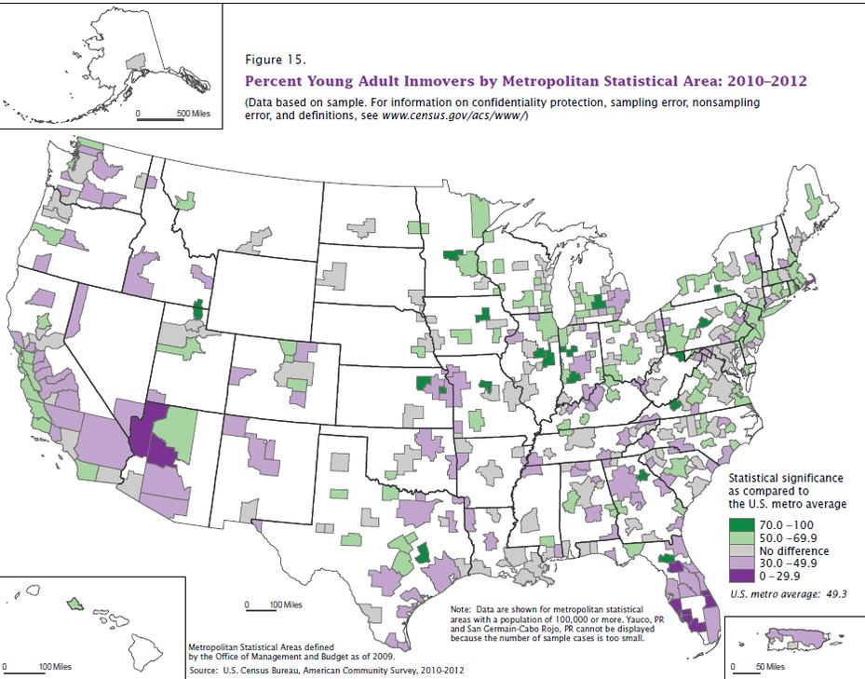

The areas in green represent cities where the age group defined as ‘millennial’ are moving, purple metro areas are not faring as well and had more moving out than in.

More opportunity and economic attention helps the city moving forward in retention of young talent and fosters future growth.

**Poverty & Crime**

It is no secret that poverty and crime are linked. Recent studies have dictated that these links are even more closely related than previously thought. Following the recession, crime rates have slowly risen nationally and some areas have seen huge spikes in crime.

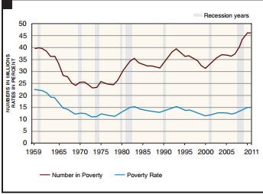

* Around 2008 the poverty rate rose slightly while the number of those in poverty skyrocketed.
* Following this uptick, violent and property crimes were on the rise.

A barometer to use for measure is the median income in cities in comparison to their crime rates. In 2013, lower Median Income cities had more crime.

* In four of the 10 metro areas, for example, more than 8% of workers were unemployed in 2013, well above the national rate. The 2013 median household income was also less than the national figure of $52,250 in four of the cities where crime has been soaring.

**Cities with incomes less than 52,250 had more crime. Louisville is at $44,000

**Cities with Increased Crime/Poverty Rates**

A recent study of metro areas around the United States compared the increase in violent crime and the increase in poverty.

Below is a snapshot of cities with increased crime statistics and poverty, and cities that improved unemployment and the economies and their drop in crimes:

**Madera-Chowchilla, CA**

* 5-year increase in violent crime rate: **46.6%**
* Violent crime per 100,000 (2009): 454.1
* Violent crime per 100,000 (2013): 665.7
* Murders per 100,000 (2013): **13.0**

Madera had a violent crime rate of 665.7 per 100,000 people in 2013, a 46.6% increase from 2009, as well as the 15th highest crime rate among all metro areas. Financial distress among residents contributed to the area’s high crime rates. Madera had a median household income of less than $40,000 in 2013, considerably lower than the national median of $52,250. Nearly 24% of residents also lived in poverty.

**Medford, OR**

* 5-year increase in violent crime rate: **80.4%**
* Violent crime per 100,000 (2009): 195.1
* Violent crime per 100,000 (2013): 352.2
* Murders per 100,000 (2013): **4.0**

Nearly half of Southern Oregon residents believed crime to be the most important issue in the area, according to a survey in late 2013. In fact, crime was considered a worse problem than the area’s unemployment rate, which in Medford was still hovering around 10% in 2013. Increasingly, gangs have become a major presence in the area, using Interstate 5, which runs through Medford, to transport drugs. Between 2009 and 2013, reported violent crimes rose by 80%, and property crimes rose by nearly 58%, both the third largest increases in the country. Aggravated assault, which accounted for more than 70% of violent crimes in the Medford area in 2013.

**Cities with Decreased Poverty Rates and Crime Rates**

**Charleston SC**

* 5-year change in violent crime rate: **-41.7%**
* Violent crime per 100,000 (2009): 616.3
* Violent crime per 100,000 (2013): 359.4
* Murders per 100,000 (2013): 51.0

The reported violent crime rate in the Charleston metro area fell by 41.7% between 2009 and 2013, from 616.3 per 100,000 residents to 359.4 per 100,000 residents. The area’s falling violent crime rate was largely driven by lower robbery and aggravated assault rates — among the most commonly committed crimes — which fell 55.7% and 39.4%, respectively. Reasons for the sharp decline in crime may be due in part to a falling unemployment rate. Between 2009 and 2013, the **unemployment rate fell from 9.5% to 6.3%,** even as the labor force grew by 5.5%, indicating that the area’s economy

**DUBUQUE, IA**

* 5-year change in violent crime rate: **-58.7%**
* Violent crime per 100,000 (2009): 387.2
* Violent crime per 100,000 (2013): 159.8
* Murders per 100,000 (2013): **0.0**

No metropolitan area reviewed had a greater drop in violent crime than Dubuque, Iowa. Less than 160 violent crimes were reported per 100,000 residents in 2013, **down nearly 60%** from 2009 when more than 387 crimes were reported per 100,000 people. Like only a handful of U.S. metropolitan areas, there were zero murders in Dubuque in 2013. Other crimes were similarly infrequent. Dubuque had an aggravated assault rate of just 104 per 100,000 people, for example, less than half the national rate of 229 per 100,000 Americans in 2013. The job market was also exceptionally strong that year, with an **unemployment rate of just 4.5%.**

**Poverty Creates Victims of Crimes as well as those who commit crimes:**

The United States Department of Justice Issued a special report in November of 2014 linking household poverty and violence.

For the period 2008–12, persons living in poor households at or below the Federal Poverty Level

(FPL) (39.8 per 1,000) had more than doubled the rate of violent victimization as persons in high-income households (16.9 per 1,000) (below).

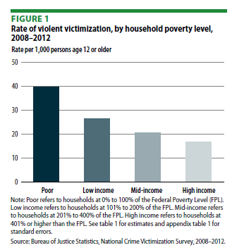

The percentage of persons reporting violence to police was also higher among households at or below the FPL. More than half of victims of violence from poor households (51%) reported the victimization to police, compared to 45% of victims from high-income households.

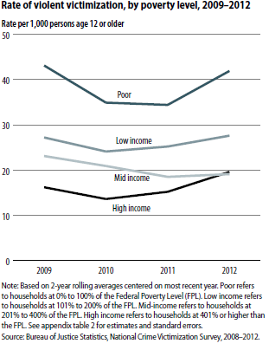

* **Living in poverty creates not only a less happy lifestyle but one of more stress of becoming a victim as well.
* Starting from the 1970’s, studies in the US pointed more and more at the link between unemployment, poverty and crime. After that other connections with income level, time spent at school, quality of neighborhood and education were revealed as well. Fresh research from the UK even indicates that economic cycles may affect variations in property and violent crimes.

**Problems with Current System**

* Poverty not only impacts your ability to live a comfortable life, it also impacts your ability to envision a world where you aren’t poor.

**Education Barriers**

* Many current students do not see the advantage of focusing or trying hard in school. A lot of them saw other loved ones who worked hard but still have nothing.
* Currently, Education is a good way to escape poverty but not enough to escape generational poverty.

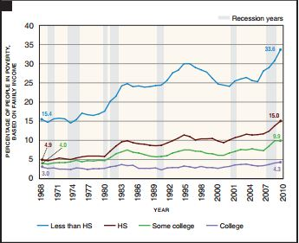

In 2010, even those with some college or college educations have seen an uptick in percentage of those individuals in poverty.

**Systemic blockage from wealth**

* Studies have shown that high crime areas in minority areas can lessen crime with black owned business being located in the community.
* In the largest decline in crime rates 2000-2010, a study conducted by Urban Affairs concluded that s the number of black-owned businesses rose, local black youth violence declined over the decade.
* Black-owned businesses act as "social buffers" their owners serve as role models to young people and create social networks that shield and divert youth people from a life of crime.
* Black businesses mitigate some of the economic factors that contribute to youth violence in these communities. They add jobs, provide employment opportunities, and generally improve the neighborhood.

The simple solution seems to be to add more black or minority owned business into high poverty areas, however there is a systemic block from doing that.

* The Wall Street Journal conducted a study showing that black small business owners are overwhelmingly denied loans.

Before the recession, black-owned small businesses received 8.2 percent of all loan money through the Small Business Administration (SBA). That figure is now down to 1.7 percent, according to an analysis by the Wall Street Journal. The total volume of loans they are currently getting is similarly low: 2.3 percent of the roughly 54,000 doled out through the agency, down from 11 percent in 2008.

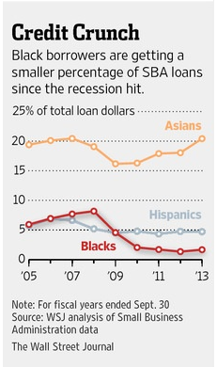

* Black Americans’ average credit score before the crisis was 25.6 out of 100, while whites’ was 54.
* Tighter lending means black wealth has taken an enormous hit from the implosion of the housing bubble and the ensuing recession, with the gap between the wealth of whites and blacks doubling.
* Black workers don’t fare much better if they decide not to start their own businesses and work for someone else’s. Employers often hire people they know who tend to be the same race as them.
  + While African-Americans have faced an elevated unemployment rate during the recession and recovery, it’s part of a longer story, as their unemployment rate is always at least 60 percent higher than for whites and since 1972

**Youth are Disheartened**

* Impoverished youth see the struggles they have and compare them to the struggles the rest of the world acknowledges.
* In a society that seems to focus on tending to the issues of the wealthy or to partisan agendas, the less fortunate are discouraged and often act out or give up hope.
* Below is a copy of one letter out of many that was written by a student at Noe Middle School about lack of things to do and how it leads to gangs. If the city can invest in people like this student then problems will dissipate:

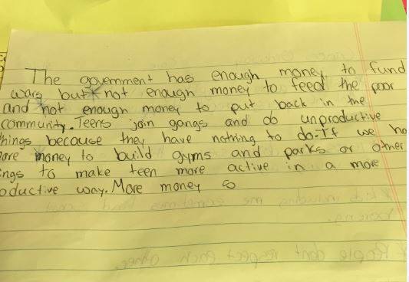

“The government has enough money to fund wars but not enough money to feed the poor and not enough money to put back in the community. Teens join gangs and do unproductive things because they have nothing to do. If we had more money to build gyms and parks or other things to make teens more active in a more productive way…”

**What can we do?**

I want to address the question over time but wanted to offer a few preliminary things that may be further examined if an office were to look into these issues.

Possible Policy choices:

* **Local Earned Income tax credit.**
  + Could also be used as offset in case of LIFT passing, can argue it makes up for the argued regressive nature.
  + KY lacks true measure.
* **Investment in minority business.**
  + Some cities offer programs that help with obtaining loans for minority businesses or credits to open minority owned businesses in select areas.
* **Two Generation poverty programs**
  + This approach often promotes joining together two types of programs to serve families. One type includes early childhood development programs such as home visiting, Head Start/Early Head Start, and successful transition to elementary school. At the same time the approach attempts to link these efforts to services such as postsecondary education and workforce development that focus on parents in their role as breadwinners. By promoting early education and supports for children along with tools to improve parents’ economic situation, the two-generation approach expects that outcomes for both will improve.
* **Reduce Structural Unemployment**
  + Public policies that aim to restructure the labor market in order to tackle structural unemployment have a clear-cut (positive) effect on income levels and economic growth. Decreasing unemployment remains central to breaking the cycle of poverty and crime and restoring some social harmony.
* Tbd.